**CHAPTER 1**

**INTRODUCTION**

In the evolving landscape of the dairy industry, innovative solutions are essential to meet the growing demand for convenience, efficiency, and hygiene. The Dairy Vending Machine represents a breakthrough in this regard, offering a modern approach to distributing dairy products. This advanced machine is equipped with cutting-edge technology, including a servo motor, an ultrasonic sensor, and a primary tank, each playing a crucial role in its operation. The servo motor ensures precise control over the dispensing process, delivering the exact amount of dairy product with each use. This level of precision minimizes waste and ensures consistency, enhancing the overall user experience. Meanwhile, the ultrasonic sensor provides real-time monitoring of product levels within the primary tank, ensuring a continuous supply and preventing both overfilling and shortages. This sensor's accuracy and reliability are critical for maintaining product availability and freshness. At the core of the Dairy Vending Machine is the primary tank, a robust and hygienic reservoir designed to store dairy products under optimal conditions.

Constructed from food-grade materials and featuring advanced temperature control systems, the primary tank ensures that products remain fresh and safe for consumption. Together, these components create a system that not only meets the demands of modern consumers but also addresses key challenges in the dairy industry. By providing 24/7 access to fresh dairy products, the Dairy Vending Machine enhances convenience for consumers while streamlining operations for producers and retailers. This Dairy Vending Machine not only modernizes the way consumers access dairy products but also streamlines the process for producers and retailers. By combining advanced technology with practical functionality, it represents a significant step forward in the distribution and consumption of dairy products, catering to the needs of a fast-paced, convenience-driven market. This innovative approach to dairy distribution represents a significant step forward, combining technological advancements with practical benefits to transform the way dairy products are accessed and enjoyed.

**CHAPTER 2**

**LITERATURE REVIEW**

The dairy industry is a critical component of Kenya's agricultural sector, contributing significantly to the economy and providing livelihoods for millions of farmers. Traditionally, the distribution of milk in Kenya has been characterized by informal markets and direct sales from farmers to consumers. However, this system often faces challenges such as contamination, spoilage, and inefficiencies in supply chain management. In response to these issues, milk dispensing machines have emerged as an innovative solution aimed at improving the quality, accessibility, and affordability of milk for consumers.Retail innovations in the dairy sector have been widely studied, with a focus on how technological advancements can enhance product quality, reduce wastage, and improve supply chain efficiency. Studies have highlighted various innovations such as automated milking systems, cold chain logistics, and digital platforms for dairy management. The introduction of milk dispensing machines represents a significant addition to these innovations, offering a direct-to-consumer approach that minimizes intermediaries and reduces the risk of contamination.

Ayuya et al. (2022) build on this body of literature by examining the specific case of milk dispensing machines in Kenya. Their research highlights the potential of these machines to address key challenges in the dairy supply chain, such as ensuring milk freshness, maintaining hygiene standards, and providing consumers with a convenient purchasing option. By reducing the reliance on traditional retail outlets, milk dispensing machines can streamline the distribution process and offer a more efficient means of getting milk from producers to consumers. The study by Ayuya et al. identifies several key trends associated with the adoption of milk dispensing machines in Kenya. One of the primary trends is the increasing urbanization and changing consumer lifestyles, which have created a demand for more convenient and accessible food products. Milk dispensing machines cater to this demand by providing an easy-to-use, 24/7 access point for fresh milk, which is particularly appealing to urban dwellers with busy schedules. Another trend highlighted in the study is the growing awareness and concern about food safety and quality among Kenyan consumers. Milk dispensing machines are perceived as a more hygienic option compared to traditional milk vendors, as they are designed to minimize human contact and maintain the milk at optimal temperatures. This aspect of the machines aligns with the broader trend of consumers seeking safer and healthier food options.The study also points to the role of government policies and support in promoting the adoption of milk dispensing machines. In Kenya, the government has been proactive in supporting dairy sector innovations through initiatives such as subsidies for equipment, training programs for farmers, and campaigns to raise awareness about the benefits of modern dairy technologies. These efforts have created a conducive environment for the introduction and uptake of milk dispensing machines.

Understanding consumer behavior is crucial for the successful adoption and scaling of any retail innovation. Ayuya et al. delve into the consumer patterns associated with milk dispensing machines, revealing several important insights. One of the key findings is the high level of consumer acceptance and satisfaction with the machines. Consumers appreciate the convenience, affordability, and quality of the milk provided by these machines, which has contributed to their growing popularity. The study also identifies demographic factors that influence consumer preferences for milk dispensing machines. For instance, younger consumers and those with higher levels of education are more likely to use the machines, indicating a correlation between technological literacy and adoption rates. Additionally, households with higher incomes are more inclined to purchase milk from dispensing machines, suggesting that affordability is a critical factor in consumer decision-making. Ayuya et al. also explore the barriers to adoption and usage of milk dispensing machines. Some of the common barriers include lack of awareness, limited access to the machines in rural areas, and initial skepticism about the quality of the milk. To overcome these barriers, the study suggests that targeted marketing campaigns, strategic placement of machines in high-traffic areas, and partnerships with local communities can be effective strategies.

The introduction of milk dispensing machines has significant implications for the dairy industry in Kenya. One of the most notable impacts is the potential for improved milk quality and safety. By reducing the number of handling points and maintaining strict temperature controls, milk dispensing machines help to preserve the freshness and nutritional value of the milk. This improvement in quality can enhance consumer trust and increase demand for dairy products. Moreover, milk dispensing machines can contribute to reducing post-harvest losses, which are a major challenge in the dairy sector. Traditional milk distribution methods often result in significant wastage due to spoilage and contamination. By providing a more efficient and controlled distribution system, milk dispensing machines can help to minimize these losses and increase the overall profitability of dairy farming. The study also highlights the economic benefits of milk dispensing machines for smallholder farmers. By providing a direct sales channel, these machines can offer farmers better prices for their milk compared to traditional middlemen. This increased income can incentivize farmers to invest in improving their production practices, leading to higher yields and better-quality milk. Additionally, the reduced reliance on middlemen can enhance the transparency and fairness of the dairy supply chain. To contextualize the findings of Ayuya et al., it is useful to compare milk dispensing machines with other retail innovations in the dairy sector. For example, automated milking systems have been widely adopted in developed countries, offering significant labor savings and improved animal welfare. However, these systems are often expensive and may not be suitable for small-scale farmers in developing countries like Kenya. In contrast, milk dispensing machines are relatively affordable and can be easily integrated into existing dairy farming practices. Another comparison can be made with mobile-based dairy management platforms, which have gained popularity in many parts of Africa. These platforms provide farmers with access to market information, veterinary services, and financial products. While these digital solutions offer valuable support to farmers, they do not directly address the challenges of milk distribution and quality control. Milk dispensing machines complement these platforms by providing a tangible solution for getting fresh milk to consumers efficiently and safely. Despite the promising benefits of milk dispensing machines, there are several challenges that need to be addressed to ensure their sustainable adoption and impact. One of the main challenges is the initial cost of the machines and the need for regular maintenance. While the study by Ayuya et al. indicates that these costs can be offset by the economic benefits, there is a need for financial support and incentives to make the machines more accessible to smallholder farmers and cooperatives.

Another challenge is the need for continuous consumer education and awareness. Ensuring that consumers understand the benefits of milk dispensing machines and trust the quality of the milk is crucial for driving adoption. This requires ongoing marketing efforts and community engagement to build and maintain consumer confidence. The study also points to the importance of developing robust supply chain logistics to support the widespread deployment of milk dispensing machines. This includes ensuring reliable power supply, regular maintenance services, and efficient milk collection and distribution networks. Addressing these logistical challenges is essential for maximizing the benefits of the machines and ensuring their long-term viability. Looking ahead, there are several areas for future research and development. One potential direction is the integration of digital technologies, such as mobile payment systems and data analytics, to enhance the functionality and user experience of milk dispensing machines. Additionally, further research is needed to explore the environmental impact of the machines and identify ways to minimize their carbon footprint. The study by

Ayuya et al. (2022) provides valuable insights into the emergence of milk dispensing machines as a retail innovation in Kenya. By examining the trends and consumer patterns associated with these machines, the research highlights their potential to transform the dairy industry by improving milk quality, reducing wastage, and providing economic benefits to farmers. However, addressing the challenges of cost, consumer education, and supply chain logistics is crucial for ensuring the sustainable adoption and impact of milk dispensing machines.

**CHAPTER 3**

**OVERVIEW OF THE PROJECT**

**3.1 Introduction**

Introducing a revolutionary solution for the dairy industry, the Dairy Vending Machine, a state-of-the-art system designed to enhance the convenience and efficiency of distributing dairy products. This innovative machine is powered by a sophisticated servo motor, ensuring precise control and reliable operation. Additionally, the integration of an ultrasonic sensor guarantees accurate measurement and management of product levels within the primary tank, preventing overflow and ensuring a consistent supply of fresh dairy products.

**3.2 Technological Overview**

**3.2.1 Servo Motor**

At the heart of the Dairy Vending Machine is the servo motor, a type of motor known for its precision and control. Servo motors are widely used in various applications, from robotics to industrial machinery, due to their ability to execute exact movements and maintain consistent performance. In the context of the Dairy Vending Machine, the servo motor is responsible for controlling the dispensing mechanism. The servo motor ensures that the correct amount of dairy product is dispensed with each use, minimizing waste and maintaining portion control. Its precise movements allow for smooth and efficient operation, reducing the likelihood of mechanical errors and ensuring that consumers receive their desired products quickly and accurately.

**3.2.2 Ultrasonic Sensor**

Another critical component of the Dairy Vending Machine is the ultrasonic sensor. This sensor uses ultrasonic waves to detect the level of liquid within the primary tank, providing real-time data on product availability. Ultrasonic sensors are known for their accuracy and reliability, making them ideal for applications where precise measurement is crucial. In the Dairy Vending Machine, the ultrasonic sensor continuously monitors the levels of dairy products in the primary tank. This information is essential for maintaining a consistent supply, preventing both overfilling and depletion. By ensuring that the primary tank is always stocked at optimal levels, the ultrasonic sensor helps to maintain the quality and freshness of the dairy products, as well as ensuring that the machine is ready to serve consumers at all times.

**CHAPTER 4**

**4.COMPONENTS DESCRIPTION**

**4.1 Introduction**

The dairy industry has long been a cornerstone of the global food economy, providing essential nutrition through products like milk, cheese, yogurt, and butter. As consumer lifestyles become increasingly fast-paced and technology continues to advance, there is a growing demand for more convenient, efficient, and hygienic methods of distributing dairy products. Enter the Dairy Vending Machine—an innovative solution designed to meet these needs. This comprehensive introduction will explore the various components of the Dairy Vending Machine, including the servo motor, ultrasonic sensor, and primary tank, and discuss how these elements work together to revolutionize the distribution of dairy products.

**4.1.1 Primary tank**

It acts as a storage area of primary source milk and it is the area which provides the input given to the secondary tank. It's providing milk for secondary tank which has various preparation for various dairy products and the supply will be depends upon the necessity of the individual secondary tank on that time period. The milk will be pre heated in the primary tank which reduces the preparation period of primary ingredient milk for the further diary product making process

**4.1.2 Secondary tank**

In Vending machine, there are multiple secondary tank which is the place for processing the input and provides the convenient outcome way to users. The purpose of the secondary tank will be different according to the dairy products which is they are individually responsible for making. The secondary tank will get its supply of milk from the primary tank and process for making the bi products like curd, butter, butter milk will be happening inside the secondary tank for example in the bi product of curd the milk will undergo some fermentation process by adding the acidic mixture to the primary ingredient milk inside the secondary tank . The availability of the bi product will be intimated and the amount of the which will be required to preparation of bi product will be declared as an intimation to the system

**4.1.3 Ultrasonic sensor**

The Ultrasonic sensor is used in Dairy Vending Machine for measuring the Milk outcomes from the Primary Tank and Secondary Tank. The Ultrasonic sensor is twice used for each tank. And the Ultrasonic sensor sensing the measurement which gives the control to servo motor and automatically switch off when the measurement level is reached and switch on when the cup is empty.

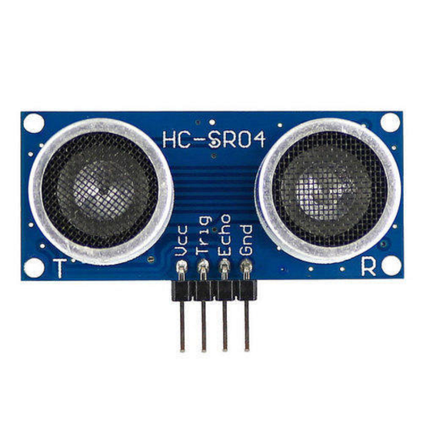

Fig 4.1 Ultrasonic Sensor

**4.1.4 Servo motor**

The Servo motor works under the positional rotation and used for closing as well as open the Secondary tank which provides the Milk. It works by the Ultrasonic sensor when the level is reached, it automatically closes the Secondary tank. And the Servo motor used in Primary tank as well as Secondary tank for closing schedule.

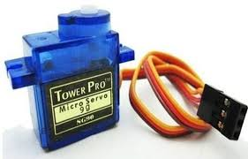

Fig 4.2 Servo Motor

**4.1.5Arduino mega or Arduino mega 2560:**

Table 4.1 Specification of Arduino Microcontroller

|  |  |
| --- | --- |
| **ARDUINO MEGA MICROCONTROLLER** | |
| Microcontroller | [ATmega2560](http://www.atmel.com/Images/Atmel-2549-8-bit-AVR-Microcontroller-ATmega640-1280-1281-2560-2561_datasheet.pdf) |
| Operating Voltage | 5V |
| Input Voltage (recommended) | 7-12V |
| Input Voltage (limit) | 6-20V |
| Digital I/O Pins | 54 (of which 15 provide PWM output) |
| Analog Input Pins | 16 |
| DC Current per I/O Pin | 20 mA |
| DC Current for 3.3V Pin | 50 mA |
| Flash Memory | 256 KB of which 8 KB used by bootloader |
| SRAM | 8 KB |
| EEPROM | 4 KB |
| Clock Speed | 16 MHz |
| LED_BUILTIN | 13 |
| Length | 101.52 mm |
| Width | 53.3 mm |
| Weight | 37 g |

The Arduino Mega, a heavyweight in the Arduino family, is a microcontroller board specifically designed for projects that require more digital and analog input/output (I/O) pins than its smaller cousin, the Arduino Uno. This makes it a favorite amongst hobbyists, students, and professionals working on intricate electronic projects. At its core, the Mega boasts the ATmega2560, a powerful 8-bit microcontroller. Compared to the Uno's 32KB of flash memory, the Mega packs a whopping 256KB, providing ample space to store your code. It also offers 8KB of SRAM for temporary data storage and 4KB of EEPROM for non-volatile storage, ensuring your project retains its settings even after a power cycle. One of the most striking features of the Arduino Mega is its I/O pin count. It offers a total of 54 digital I/O pins. These pins can be configured as either inputs, to read signals from sensors like temperature sensors or buttons, or outputs, to control devices like LEDs or motors. Additionally, it provides 16 analog input pins that can convert analog voltage signals from sensors into digital values for easy processing by the microcontroller. If you're looking to control the brightness of LEDs or the speed of motors with more precision, the Mega comes equipped with 14 of its digital pins configured for PWM (Pulse Width Modulation).

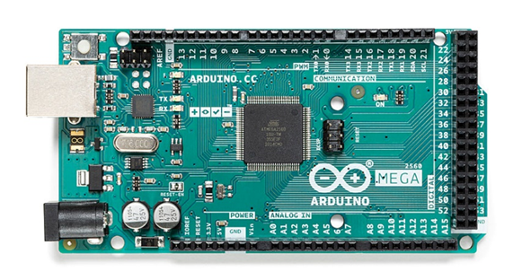

Fig 4.3 Arduino Mega or Arduino Mega 2560

Communication is another forte of the Arduino Mega. It includes a serial port, allowing you to connect it to your computer for programming and debugging your code. This serial port also paves the way for connecting additional hardware modules like Bluetooth or Wi-Fi, giving your project wireless capabilities. But that's not all! The Mega also boasts SPI (Serial Peripheral Interface) and I2C (Inter-Integrated Circuit) communication capabilities, enabling it to interact with a wide range of other electronic components, further expanding your project's horizons. Powering the Arduino Mega is flexible. It can be powered via a USB cable from your computer, a DC power jack, or even a battery. The board itself regulates the voltage to ensure safe operation for your project's components.

**4.1.6 SOLUTION MIXTURE**

The Dairy Vending Machine provides the multiple outcomes like curd, yogurt, butter. For that we need to add some content to milk which is produce the multiple outcomes. So the solution mixture is added to the vending machine and it provides the product for customer in customization way.

**4.1.7 MEMBRANE KEYPAD**

Membrane keypad is used for read the input from the customer. It is in the form of cost. Customer can type their cost as an input. Based on the cost the vending machine provides the quantity of the product.



Fig 4.4 Keypad Membrane

**4.1.8 DISPLAY**

It displays the information about the machine and also displays the method to select the cost, type of product and payment configurations.

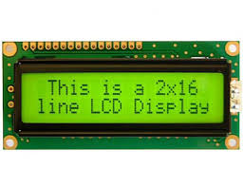

Fig 4.5 LCD Display

**CHAPTER-5**

**5. PROPOSED SOLUTION**

**5.1 Block Diagram**

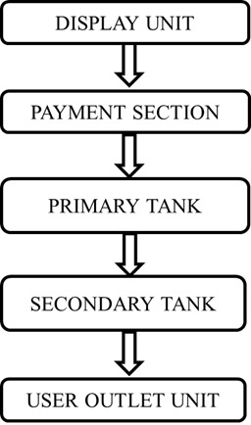

5.1. Block diagram for Diary Vending Machine

**5.2 Flow Chart**

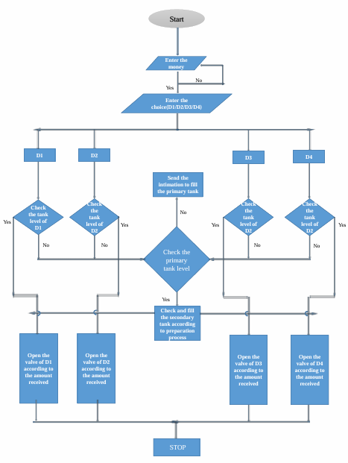

5.2. Flowchart for Diary Vending Machine

**CHAPTER 6**

**RESULTS AND CONCLUSION**

In today's fast-paced world, convenience and accessibility are paramount in meeting consumer needs. Traditional retail models are undergoing significant transformations, and the dairy industry is no exception. The introduction of dairy vending machines represents a novel approach to providing consumers with fresh, high-quality dairy products in a convenient and efficient manner. This comprehensive conclusion will delve into the evolution of dairy vending machines, their impact on the dairy industry, technological advancements, consumer preferences, challenges, and future prospects.Dairy vending machines have emerged as a disruptive innovation in the retail sector, reshaping the way consumers access milk and other dairy products. Historically, consumers relied on conventional retail channels such as supermarkets, grocery stores, and local dairies for their dairy needs. However, the rise of vending machines has introduced a new paradigm, offering unparalleled convenience and flexibility. From the early prototypes to the sophisticated machines of today, dairy vending machines have undergone a remarkable evolution driven by advancements in technology, consumer preferences, and market dynamics. The advent of dairy vending machines has had a profound impact on the dairy industry, disrupting traditional distribution channels and business models. These machines enable dairy farmers and producers to bypass intermediaries and directly connect with consumers, thereby reducing costs, increasing profit margins, and fostering greater transparency in the supply chain. Moreover, dairy vending machines facilitate the delivery of fresh, locally sourced dairy products, catering to the growing demand for sustainable, farm-to-table options. By decentralizing distribution and fostering direct relationships between producers and consumers, dairy vending machines are revitalizing the dairy industry and creating new opportunities for growth and innovation. Technological advancements play a pivotal role in the evolution of dairy vending machines, enabling enhanced functionality, automation, and user interaction. Modern vending machines are equipped with state-of-the-art components such as LCD displays, touchscreens, RFID readers, IoT sensors, and automated payment systems, offering a seamless and immersive experience for consumers. These machines utilize advanced algorithms and data analytics to optimize inventory management, predict consumer preferences, and personalize recommendations.

Furthermore, the integration of robotics, AI, and machine learning algorithms enables autonomous operation, real-time monitoring, and predictive maintenance, ensuring maximum uptime and reliability. Consumer preferences and behavior play a crucial role in shaping the design, functionality, and usability of dairy vending machines. Today's consumers prioritize convenience, freshness, and health-consciousness when making purchasing decisions, driving demand for on-the-go solutions and locally sourced products. Dairy vending machines cater to these preferences by providing a convenient, 24/7 access point for fresh milk, yogurt, cheese, and other dairy items. Moreover, customization options, such as portion control, flavor selection, and dietary preferences, empower consumers to tailor their shopping experience to their individual needs and preferences. As consumers increasingly embrace digital and contactless payment methods, dairy vending machines are adapting to accommodate these preferences, offering seamless integration with mobile payment platforms and contactless payment options. Despite their many benefits, dairy vending machines also face several challenges, including regulatory compliance, sanitation standards, maintenance costs, and competition from traditional retailers. Ensuring compliance with food safety regulations and maintaining strict hygiene standards is paramount to safeguarding consumer health and trust. Additionally, the upfront costs associated with purchasing, installing, and maintaining vending machines can be prohibitive for small-scale producers, necessitating innovative financing models and collaborative partnerships.

However, these challenges are accompanied by significant opportunities for growth and expansion. As consumer awareness of the environmental impact of food production grows, there is a growing demand for sustainable, locally sourced dairy products, creating new opportunities for dairy vending machine operators to capitalize on this trend. Furthermore, the proliferation of smart vending technologies, such as cloud-based inventory management systems, predictive analytics, and remote monitoring capabilities, enables operators to optimize operations, minimize downtime, and maximize profitability.

**CHAPTER 7**

**FUTURE SCOPE**

Looking ahead, the future of dairy vending machines appears promising, driven by ongoing technological advancements, changing consumer preferences, and market dynamics. As the adoption of IoT, AI, and robotics accelerates, dairy vending machines will become increasingly intelligent, autonomous, and interconnected, offering personalized recommendations, predictive maintenance, and frictionless shopping experiences. Moreover, the integration of blockchain technology holds the potential to enhance transparency, traceability, and trust across the dairy supply chain, enabling consumers to verify the authenticity and provenance of dairy products. Furthermore, the proliferation of vending machines in non-traditional locations, such as office buildings, schools, airports, and transportation hubs, will expand the reach and accessibility of dairy products to new and underserved markets. In conclusion, dairy vending machines represent a transformative innovation in the dairy industry, revolutionizing the way consumers access, purchase, and consume dairy products. By leveraging advanced technologies, catering to changing consumer preferences, and addressing key challenges, dairy vending machines have the potential to drive growth, innovation, and sustainability in the dairy sector. As the market continues to evolve, stakeholders across the dairy value chain must collaborate, innovate, and adapt to capitalize on the immense opportunities presented by dairy vending machines and ensure a bright and prosperous future for the dairy industry.

**REFERENCES**

* 1. S. Pranav Vishwas, V. V. Addala and R. K. Megalingam, "Vending Machine for Water using Verilog," 2023 4th IEEE Global Conference for Advancement in Technology (GCAT), Bangalore, India, 2023, pp. 1-5, doi: 10.1109/GCAT59970.2023.10353450.
  2. Ayuya, O. I., Kilelu, C., Ndambi, A., Ireri, D. M., & van der Lee, J. (2022). Emergence of Milk Dispensing Machines as a Retail Innovation in Kenya: Trends and Consumer Patterns. Journal of International Food & Agribusiness Marketing, 1–20. doi: 10.1080/08974438.2022.2156962
  3. S. F. Ali, S. Imran and N. Devi K, "A Smart and Systematic Ration Grocery and Liquid Materials Vending Machine using Internet of Things," 2023 6th International Conference on Recent Trends in Advance Computing (ICRTAC), Chennai, India, 2023, pp. 778-783, doi: 10.1109/ICRTAC59277.2023.10480786.
  4. S. K, N. P, D. M, R. J, S. M and M. M, "Depiction of FPGA Based Vending Machine Using Mealy Model," 2022 Third International Conference on Smart Technologies in Computing, Electrical and Electronics (ICSTCEE), Bengaluru, India, 2022, pp. 1-5, doi: 10.1109/ICSTCEE56972.2022.10099962.
  5. B. Raviteja, K. A. Pandya, F. Khan, Z. Tufail Khan, R. Prajwal and A. Kekatpure, "Smart Supply Chain Management using Big Data Analysis and Machine Learning," 2022 International Conference on Edge Computing and Applications (ICECAA), Tamilnadu, India, 2022, pp. 190-193, doi: 10.1109/ICECAA55415.2022.9936359
  6. M. Suthar, "A Novel Implementation of FPGA Based Smart Vending Machine," 2021 IEEE International Conference on Technology, Research, and Innovation for Betterment of Society (TRIBES), Raipur, India, 2021, pp. 1-6, doi: 10.1109/TRIBES52498.2021.9751636.
  7. M. A. Al-Shareeda, M. Anbar, I. H. Hasbullah and S. Manickam, "Survey of Authentication and Privacy Schemes in Vehicular ad hoc Networks," in IEEE Sensors Journal, vol. 21, no. 2, pp. 2422-2433, 15 Jan.15, 2021, doi: 10.1109/JSEN.2020.3021731.
  8. J. Guo and Y. Liu, "The design and implementation of a vending machine based on state machine, FPGA and microcontroller," 2021 IEEE International Conference on Electrical Engineering and Mechatronics Technology (ICEEMT), Qingdao, China, 2021, pp. 525-528, doi: 10.1109/ICEEMT52412.2021.9601812.
  9. C. -J. Chen, B. -R. Lin, C. -H. Lin, C. -F. Chen and M. -F. Tsai, "Smart Vending Machine System Prototyped with Deep- and Machine-Learning Technologies," 2020 IEEE International Conference on Consumer Electronics - Taiwan (ICCE-Taiwan), Taoyuan, Taiwan, 2020, pp. 1-2, doi: 10.1109/ICCE-Taiwan49838.2020.9258152.